**Database Management System Lab**

Code: PMDS506P

**Digital Assignment 3**

**Name: Soumyadeep Ganguly**

**Reg. No.: 24MDT0082**

**Course: M.Sc in Data Science**

**Q1. Create the following tables and answer the following questions.**

1. **Retrieve all customers and their corresponding salesmen's names using an inner join.**

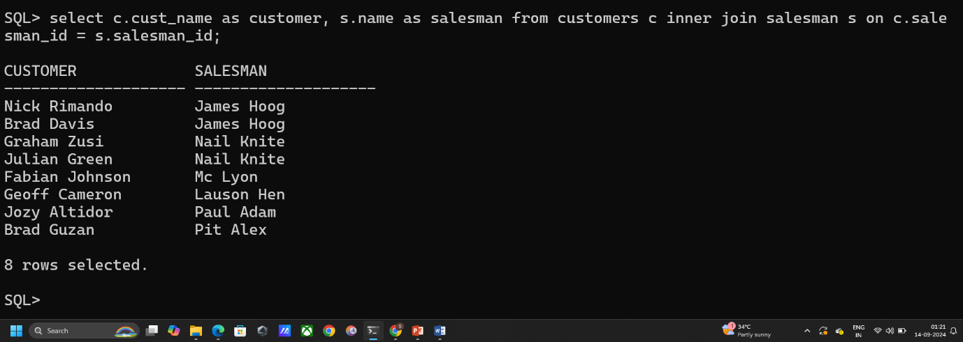SELECT C.CUST_NAME AS CUSTOMER, S.NAME AS SALESMAN FROM CUSTOMERS C INNER JOIN SALESMAN S ON C.SALESMAN_ID = S.SALESMAN_ID;

1. **Find all customers and their respective salesmen where the customer's city is the same as the salesman's city.**

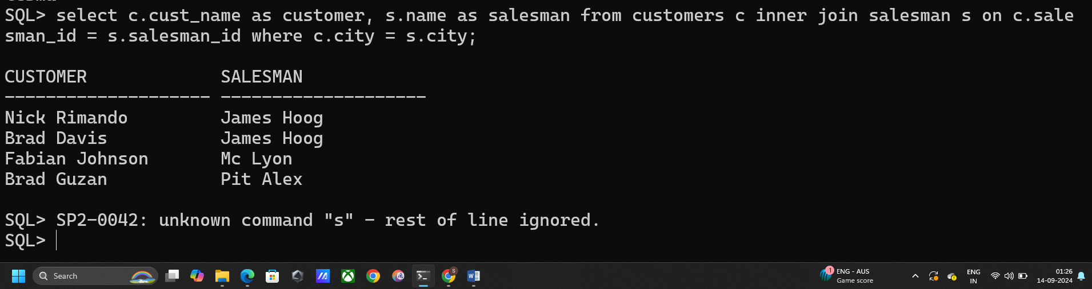SELECT C.CUST_NAME AS CUSTOMER, S.NAME AS SALESMAN FROM CUSTOMERS C INNER JOIN SALESMAN S ON C.SALESMAN_ID = S.SALESMAN_ID WHERE C.CITY = S.CITY;

1. **Show all customers along with their salesmen's details who have a grade higher than 200.**

SELECT C.CUST_NAME AS CUSTOMER, S.NAME AS SALESMAN FROM CUSTOMERS C INNER JOIN SALESMAN S ON C.SALESMAN_ID = S.SALESMAN_ID WHERE C.GRADE >200;

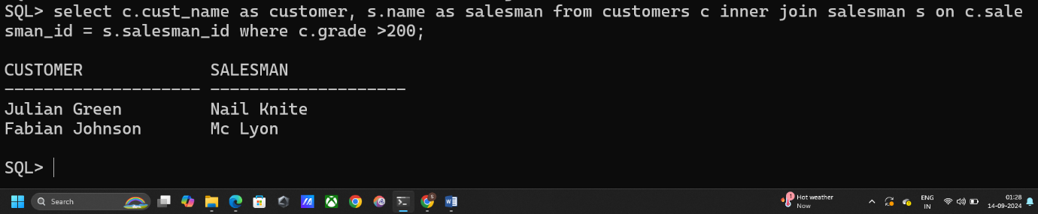

1. **Find customers in Paris and their corresponding salesmen’s names.**

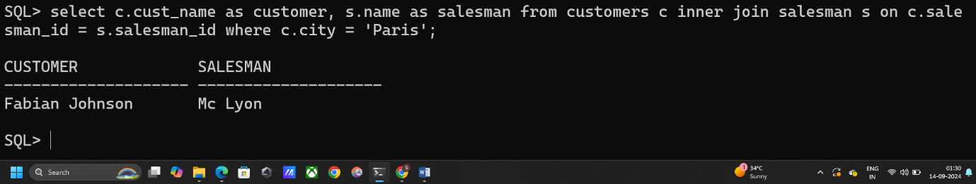SELECT C.CUST_NAME AS CUSTOMER, S.NAME AS SALESMAN FROM CUSTOMERS C INNER JOIN SALESMAN S ON C.SALESMAN_ID = S.SALESMAN_ID WHERE C.CITY = 'PARIS';

1. **Retrieve the customer_id and the name of the salesman who serves them.**

SELECT C.CUST_NAME AS CUSTOMER, S.NAME AS SALESMAN FROM CUSTOMERS C INNER JOIN SALESMAN S ON C.SALESMAN_ID = S.SALESMAN_ID;

1. **List all customers whose salesmen have a commission greater than 0.12.**

SELECT C.CUST_NAME, S.NAME AS SALES_NAME, S.COMMISSION AS SALES_COMMISSION FROM CUSTOMERS C INNER JOIN SALESMAN S ON C.SALESMAN_ID = S.SALESMAN_ID WHERE S.COMMISSION >0.12;

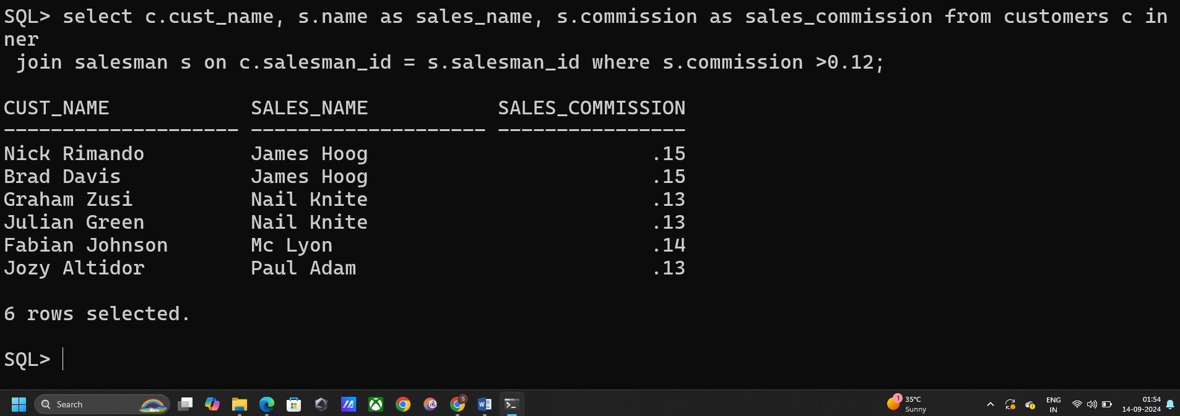

1. **Find the total number of customers each salesman has, using an inner join.**

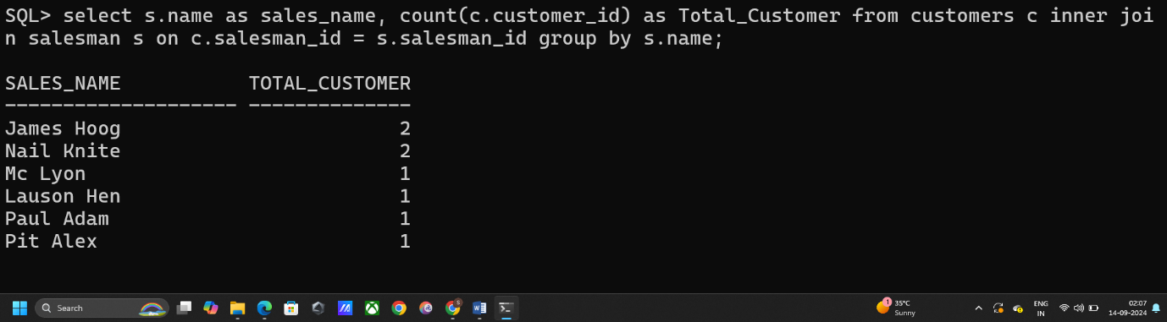SELECT S.NAME AS SALES_NAME, COUNT(C.CUSTOMER_ID) AS TOTAL_CUSTOMER FROM CUSTOMERS C INNER JOIN SALESMAN S ON C.SALESMAN_ID = S.SALESMAN_ID GROUP BY S.NAME;

1. **Retrieve all salesmen who have at least one customer.**

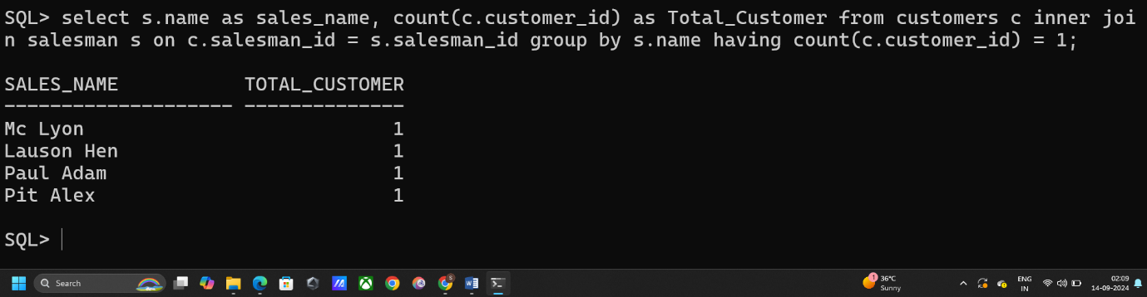SELECT S.NAME AS SALES_NAME, COUNT(C.CUSTOMER_ID) AS TOTAL_CUSTOMER FROM CUSTOMERS C INNER JOIN SALESMAN S ON C.SALESMAN_ID = S.SALESMAN_ID GROUP BY S.NAME HAVING COUNT(C.CUSTOMER_ID) = 1;

1. **Retrieve all salesmen and their customers using a left outer join.**

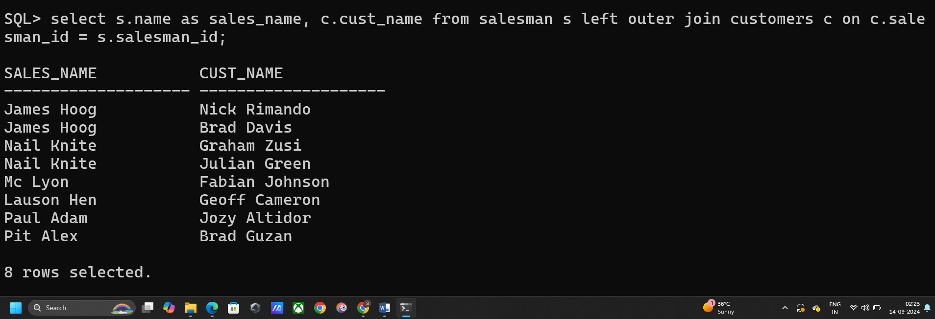SELECT S.NAME AS SALES_NAME, C.CUST_NAME FROM SALESMAN S LEFT OUTER JOIN CUSTOMERS C ON C.SALESMAN_ID = S.SALESMAN_ID;

1. **List all customers and their respective salesmen using a right outer join.**

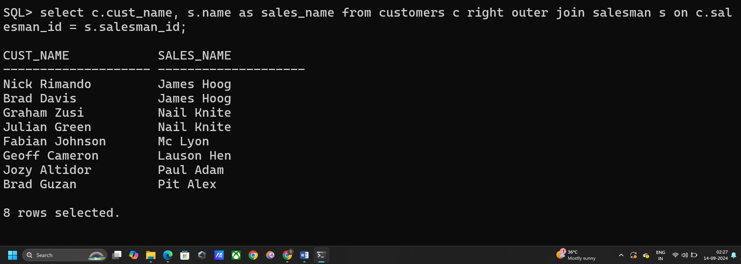SELECT C.CUST_NAME, S.NAME AS SALES_NAME FROM CUSTOMERS C RIGHT OUTER JOIN SALESMAN S ON C.SALESMAN_ID = S.SALESMAN_ID;

1. **Retrieve all customers even if they don't have a corresponding salesman.**

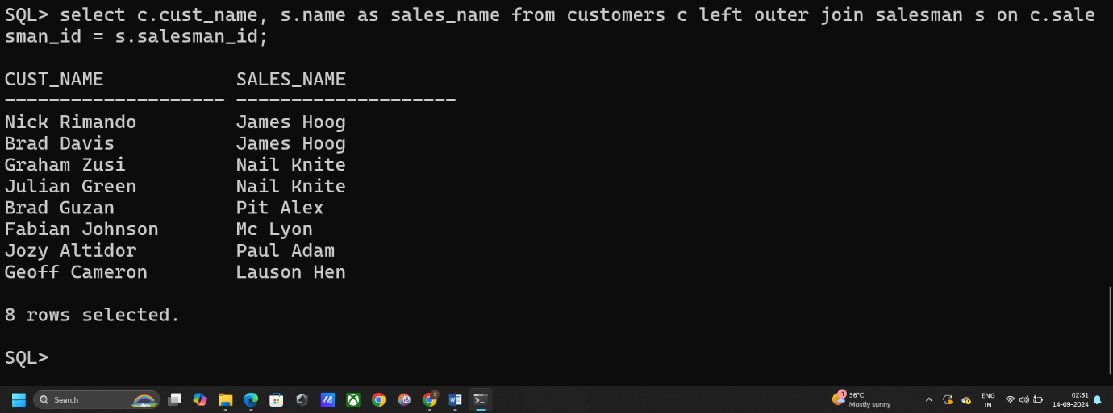SELECT C.CUST_NAME, S.NAME AS SALES_NAME FROM CUSTOMERS C LEFT OUTER JOIN SALESMAN S ON C.SALESMAN_ID = S.SALESMAN_ID;

1. **Show all salesmen along with the customer names they serve, even if the salesman has no customers.**

SELECT S.NAME AS SALES_NAME, C.CUST_NAME FROM SALESMAN S LEFT OUTER JOIN CUSTOMERS C ON C.SALESMAN_ID = S.SALESMAN_ID;

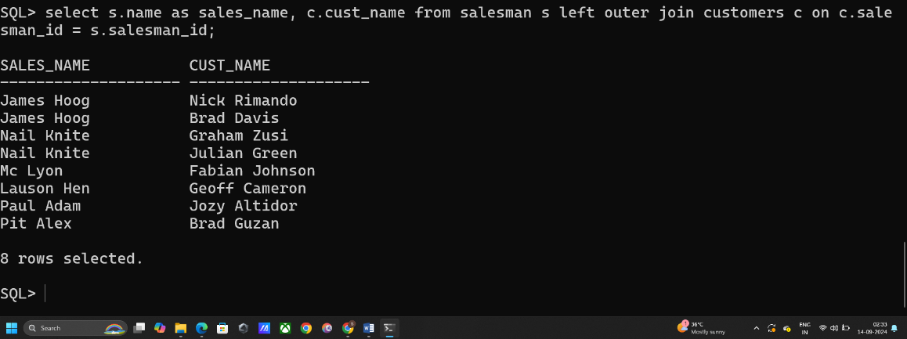

1. **Find all salesmen in Paris and list their customers, including those who don’t have any customers.**

SELECT S.NAME AS SALES_NAME, C.CUST_NAME FROM SALESMAN S LEFT OUTER JOIN CUSTOMERS C ON C.SALESMAN_ID = S.SALESMAN_ID WHERE S.CITY = 'PARIS';

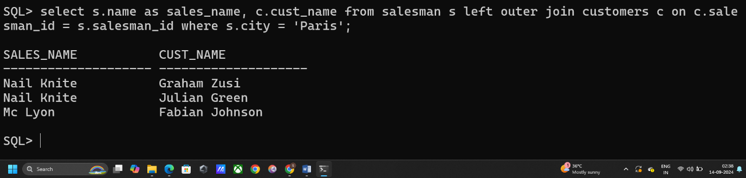

1. **Show all customers and their corresponding salesmen’s details using a full outer join.**

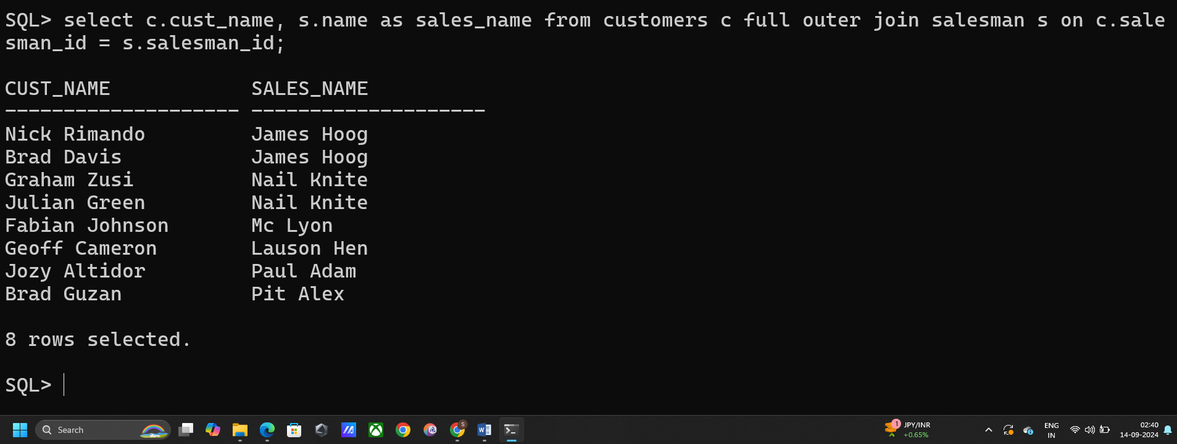SELECT C.CUST_NAME, S.NAME AS SALES_NAME FROM CUSTOMERS C FULL OUTER JOIN SALESMAN S ON C.SALESMAN_ID = S.SALESMAN_ID;

1. **Find pairs of salesmen working in the same city.**

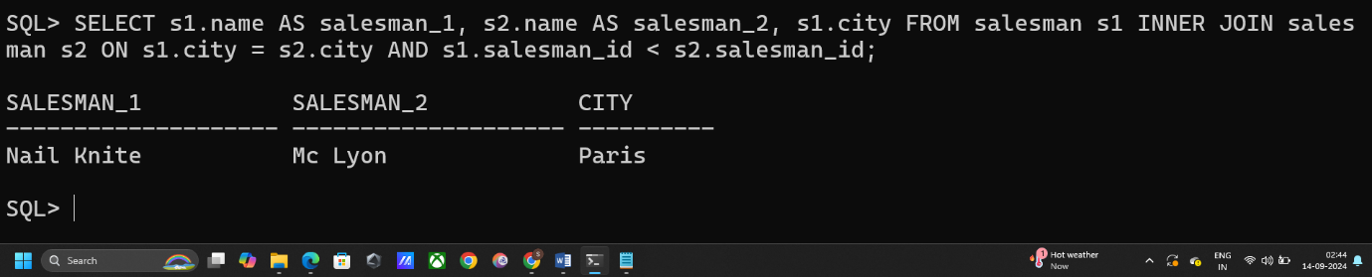SELECT S1.NAME AS SALESMAN_1, S2.NAME AS SALESMAN_2, S1.CITY FROM SALESMAN S1 INNER JOIN SALESMAN S2 ON S1.CITY = S2.CITY AND S1.SALESMAN_ID < S2.SALESMAN_ID;

1. **Find salesmen in New York who have colleagues also in New York.**

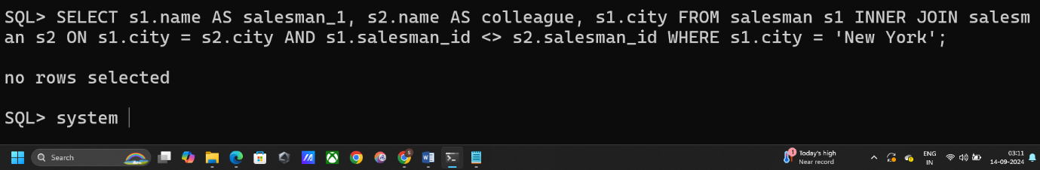SELECT S1.NAME AS SALESMAN_1, S2.NAME AS COLLEAGUE, S1.CITY FROM SALESMAN S1 INNER JOIN SALESMAN S2 ON S1.CITY = S2.CITY AND S1.SALESMAN_ID <> S2.SALESMAN_ID WHERE S1.CITY = 'NEW YORK';

1. **List all salesmen pairs who are from different cities.**

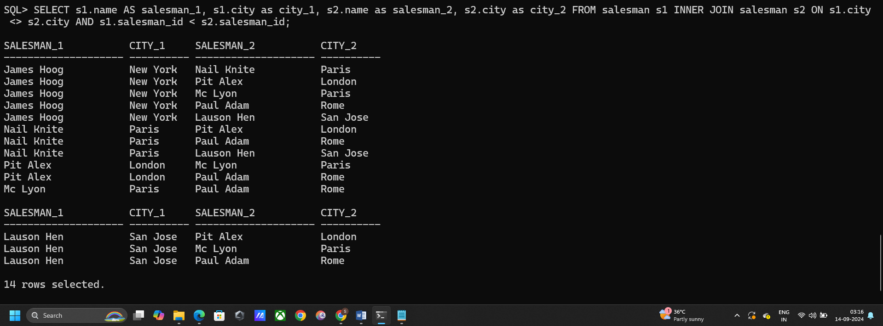SELECT S1.NAME AS SALESMAN_1, S1.CITY AS CITY_1, S2.NAME AS SALESMAN_2, S2.CITY AS CITY_2 FROM SALESMAN S1 INNER JOIN SALESMAN S2 ON S1.CITY <> S2.CITY AND S1.SALESMAN_ID < S2.SALESMAN_ID;

1. **Retrieve the Cartesian product of all salesmen and customers.**

SELECT S.NAME AS SALESMAN_NAME, C.CUST_NAME AS CUSTOMER_NAME FROM SALESMAN S CROSS JOIN CUSTOMERS C;

1. **List all pairs of customers with all pairs of salesmen using a cross join.**

SELECT C1.CUST_NAME AS CUSTOMER_1, C2.CUST_NAME AS CUSTOMER_2, S1.NAME AS SALESMAN_1, S2.NAME AS SALESMAN_2 FROM CUSTOMERS C1 CROSS JOIN CUSTOMERS C2 CROSS JOIN SALESMAN S1 CROSS JOIN SALESMAN S2 WHERE C1.CUSTOMER_ID < C2.CUSTOMER_ID AND S1.SALESMAN_ID < S2.SALESMAN_ID;

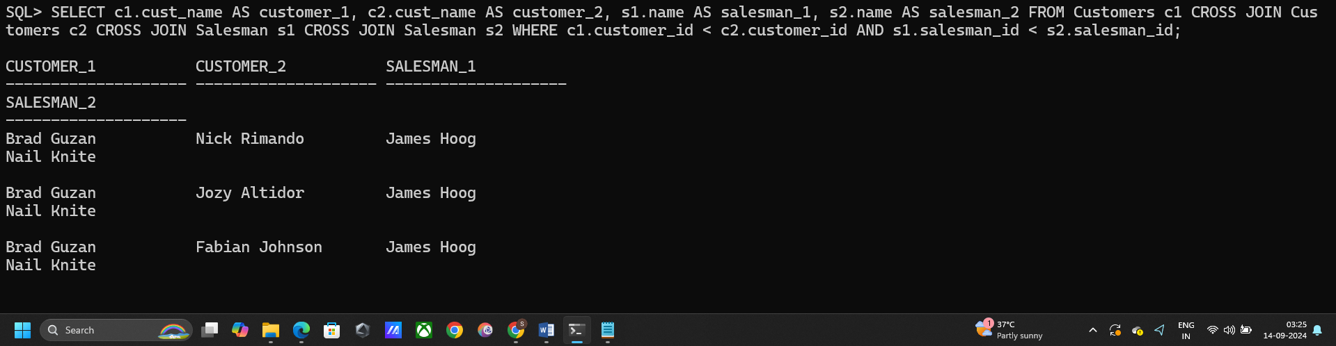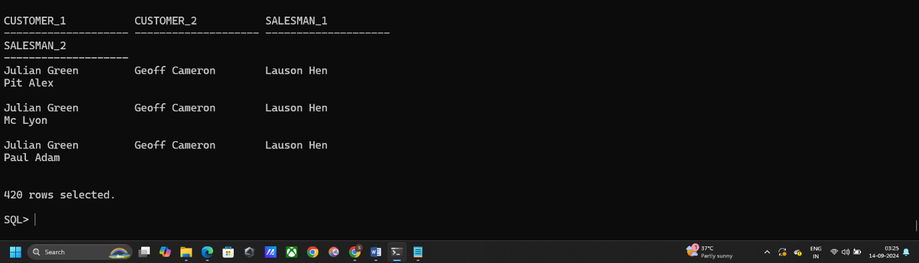

1. **Perform a natural join to retrieve all customers and their corresponding salesmen.**

SELECT CUST_NAME, NAME FROM CUSTOMERS NATURAL JOIN SALESMAN;

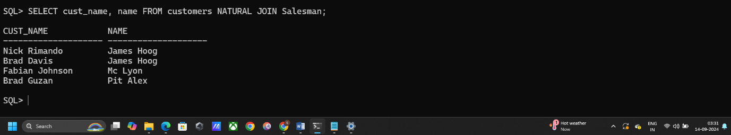

**Q2. Using the same tables in Q1, use subqueries idea to find the following.**

1. **Find the names of all salesmen who have customers in the city of "New York."**

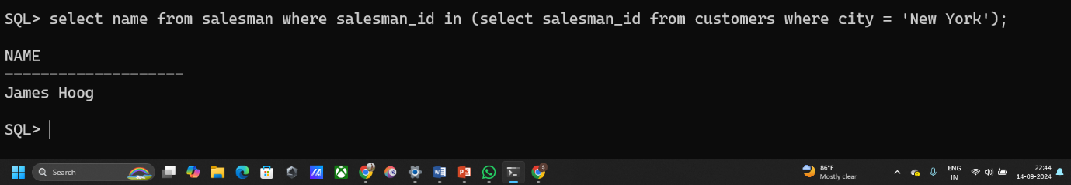SELECT NAME FROM SALESMAN WHERE SALESMAN_ID IN (SELECT SALESMAN_ID FROM CUSTOMERS WHERE CITY = 'NEW YORK');

1. **Retrieve the cust_name of customers whose salesman has a commission greater than 0.13.**

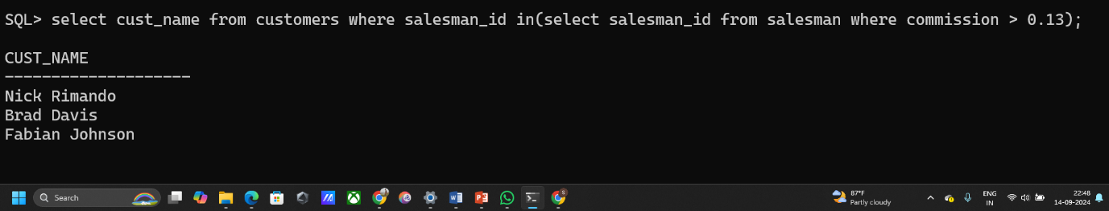SELECT CUST_NAME FROM CUSTOMERS WHERE SALESMAN_ID IN(SELECT SALESMAN_ID FROM SALESMAN WHERE COMMISSION > 0.13);

1. **List all salesmen who serve more than two customers.**

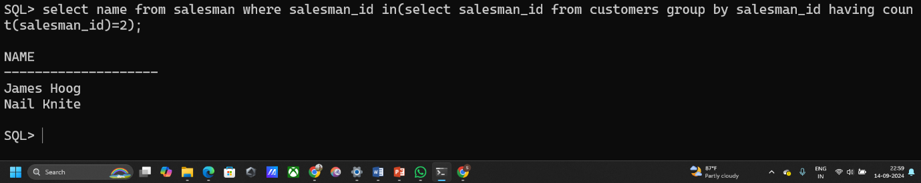SELECT NAME FROM SALESMAN WHERE SALESMAN_ID IN(SELECT SALESMAN_ID FROM CUSTOMERS GROUP BY SALESMAN_ID HAVING COUNT(SALESMAN_ID)=2);

1. **Find the names of customers who have the same city as any salesman.**

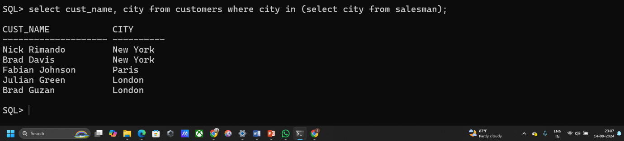SELECT CUST_NAME, CITY FROM CUSTOMERS WHERE CITY IN (SELECT CITY FROM SALESMAN);

1. **Retrieve the details of the salesman with the highest commission.**

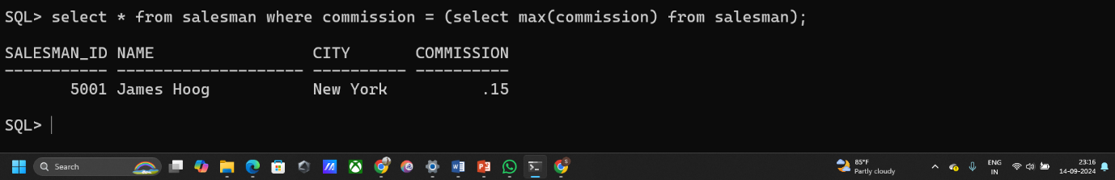select * from salesman where commission = (select max(commission) from salesman);

1. **List the customer_id and cust_name of customers whose salesmen work in "Paris.**

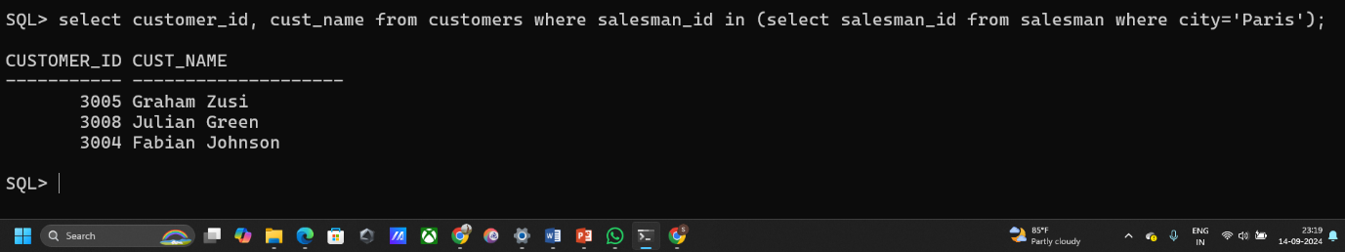SELECT CUSTOMER_ID, CUST_NAME FROM CUSTOMERS WHERE SALESMAN_ID IN (SELECT SALESMAN_ID FROM SALESMAN WHERE CITY='PARIS');

1. **List all customers who are served by salesmen from cities other than their own.**

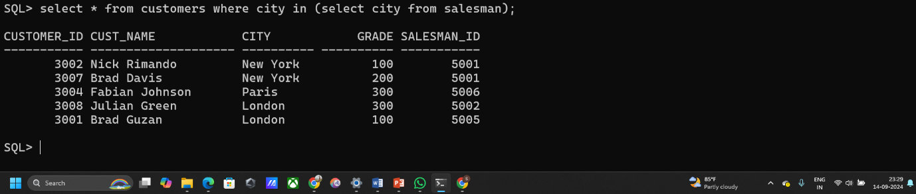SELECT * FROM CUSTOMERS WHERE CITY IN (SELECT CITY FROM SALESMAN);

1. **Retrieve the name of salesmen whose commission is greater than the commission of any salesman from "London."**

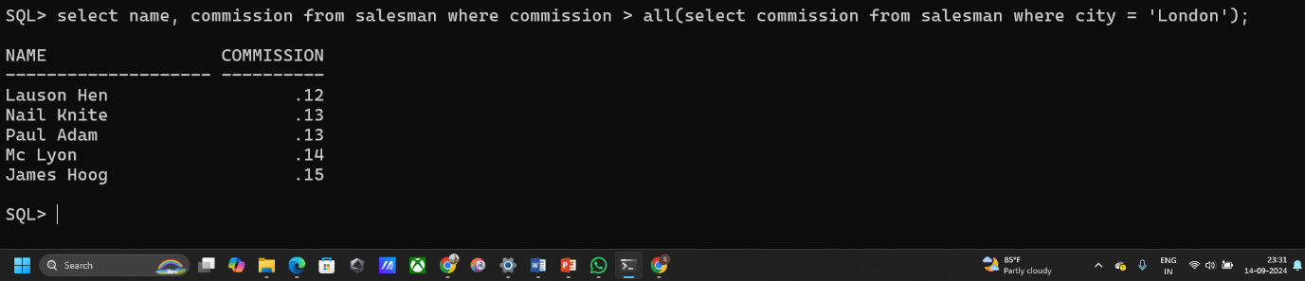SELECT NAME, COMMISSION FROM SALESMAN WHERE COMMISSION > ALL(SELECT COMMISSION FROM SALESMAN WHERE CITY = 'LONDON');